Scientific goal of the project (description of the problem to be solved, research questions and hypotheses, compliance with the objective of the call);
The aim of this project is to mathematically model a viable way out of the quarantine measures applied during the COVID-19 outbreak in Poland. While at present the goal of enforced measures is to slow down the development of the epidemic so that the number of patients that require intensive care is within the capacity of the healthcare system, at some point the quarantine period has to end. It has been predicted by computational modeling that once the general lockdown ends together with the social distancing, within 1-2 months the epidemic will develop again, and will keep reappearing until the population gains group immunity (Ferguson et al. 2020). It is therefore of paramount importance to identify optimal exit strategy: timeline and scope of decisions on relaxation or enforcement of restrictions, which would be economically and psychologically sustainable (unlike the very long lockdown scenario), and effective epidemiologically. Numerical simulations will be supported by the analysis of the historical, ethical and sociological issues, necessary for estimation of factors, which need to be included to improve the predictive power of our model. It will be possible within trans-disciplinary character of the Center of Systematic Risk, which has been established at The Robert Zajonc Institute for Social Studies of University of Warsaw and includes physicists (including atmospheric geophysicists, experts in modeling complex systems and computational physics), social scientists, biologists, psychologists, along with ethics and media analysts (see a list of co-investigators). Our project addresses item 2 of the call (mechanisms of transmission) along with item 3 (psychological and societal consequences of the pandemics and the methods of containment).
2) significance of the project (state of the art, justification for tackling a specific scientific problem, justification for the pioneering nature of the project, the impact of the project results, including the objective of the call);
In general, one may distinguish two complementary modeling approaches to the dynamics of epidemics. One is based on the agent dynamics tracing connections and interactions among individuals. This class of models can be very elaborate and include big data sets for population density distribution in focal regions, including infrastructure, transport, trade, and all sorts of agent-to-agent interactions. This approach, while computationally intensive, is successfully used to simulate recurring influenza epidemics (e.g., Rakowski et al. 2010). There is another class of models, incorporating both stochastic and deterministic descriptions (Keeling and Rohani, 2007). The latter is a tool for estimating probability distributions of potential outcomes by allowing for random variation in one or more inputs over time. They depend on the chance variations in risk of exposure, disease and other illness dynamics.
Ferguson et al. (2020) using their agent-based model tested a strategy of periodic lockdown of schools and universities while removing other quarantine measures after a long initial lockdown period. Using UK population data, they found a range of parameters of this strategy, which keeps the predicted number of COVID-19 patients that require intensive care within the capacity of the healthcare system and prevents exponential growth of the infected population. Just before submission of this proposal, the SEIR-type model together with an ingenious and potentially sustainable exit-strategy was published by Karin et al (2020). To our knowledge, however, no attempts have been made to optimize these strategies, and perform feasibility studies of their implementation. The question of a choice of optimal exit-strategies is therefore still open. Thus, in our opinion, the proposed modeling effort is timely and will fill an important gap, particularly with regard to the need of custom-made predictions for Poland.

3) concept and work plan (general work plan, specific research goals, results of preliminary research, risk analysis);
We propose to create a flexible implementation of a model of the epidemic, based on SEIR+ methodology which includes demographics and known social contact matrices (Prem et al. 2017). We will use is a combination of age-structured SEIR models recently introduced to study COVID-19 epidemics in Asia (Singh and Adhikari 2020). The model will be flexible enough, so that new ideas from psychology, and economics, including the effects of fear, psychological burnout, prolonged unemployment (Tyler et al. 1996, Wang et al. 2020) — all can be readily incorporated to the model. The equations of the model will include the heuristic behavior-inspired terms, but in contrast to the original model (Singh and Adhikari, 2020) we have the potential to determine them selectively and independently for different age groups. Models based on coupled differential equations (in contrast to agent-based models) are computationally efficient, and allows for fast testing of a large number of exit-strategies, including possible demographic restrictions (e.g., lifting various restrictions on social distancing at certain times for people of certain ages and certain professions).
In order to mitigate the risk of using irrelevant and unrepresentative data to predict the future development of epidemics and increase the predictive power of the model, we will adopt several strategies. We will use predictive techniques of stochastic models from other areas (e.g. meteorology), where similar problems of estimating parameters occur. To evaluate the relevance of parameters we will apply our models retrospectively to the known, widely described and a posteriori modeled epidemics of influenza, SARS, and MERS. In order to improve the robustness of the predictions from deterministic models we plan to apply methods of ensemble prediction, used with great success in weather and climate forecasting (Kalnay and Dalcher 1987), with just a few implementations in modeling of other phenomena (Leutbecher and Palmer, 2008; Smith 2001; Jacob et al. 2015; Reich 2020 ). In principle the method allows for a priori Bayesian determination of forecasting probability and its change in time (Marty et al. 2015). In the standard formulation, the method is used to deal with the problem of the uncertainty in the initial condition on the evolution of the state of the nonlinear system. Instead of a single forecast, an ensemble of forecasts initiated from the various states in the vicinity of the initial conditions are calculated and compared. Various measures of the ensemble spread as a function of time are used to estimate possible volume of states and forecast strength. The best and the worst, as well as most likely scenarios and critical moments in the evolution of disease spread can be potentially detected.

4) research methodology (underlying scientific methodology, methods, techniques and research tools, methods of results analysis, equipment and devices to be used in research);
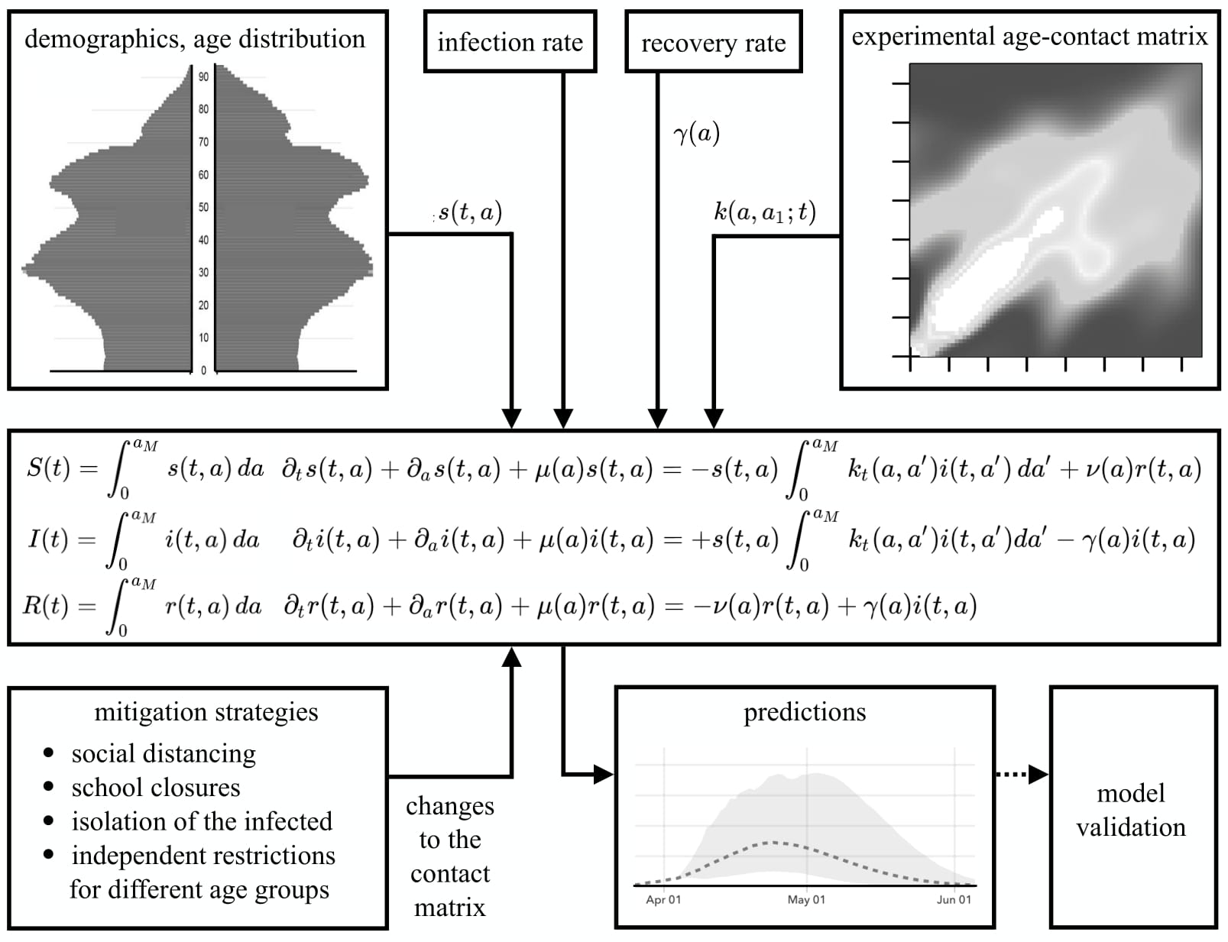
Due to the specific features of the COVID-19 disease — namely huge differences in mortality between different age groups (minors and young adults vs. elderly) the demographics has to be included in the predictions. We plan on dealing with the population of Poland, and our approach will be based on compartmental mathematical models where individuals in the population are assigned to different subpopulations and/or spatial compartments, each representing a specific stage of the infection: S (susceptible), E (exposed), I (infected), R (recovered) — with possible further subdivisions and subclasses, e.g., H (hospitalized), and D (deceased). The transition rates from one class to another are mathematically expressed as derivatives, hence the model is formulated using coupled differential equations as depicted below:
The population dynamics is modeled by means of a number of functions describing the number and age-distribution of the susceptible s(t, a), exposed e(t, a), infected i(t, a) and recovered r(t, a) subpopulations, with the first variable being the time and the second being the age. The integration over the age variable returns the age independent data of the SEIR subpopulations. The resulting system of coupled partial differential equations can be solved numerically. The initial data can be taken from the official demographic data and estimated numbers of people who were infected and number of those who recovered — both numbers unfortunately can only be roughly estimated.
The probabilities of infections in the model will depend on demographic distribution, age-dependent frequency of contacts — both of which are available including extensive (100,000 participants) study of the age structure of social contacts (Mossong at al. 2008). It is important to note that since the collection of these data till now the age distribution in Poland has changed significantly, so the time evolution of the contact matrix has to be taken into account. We will use demographic data together with further studies how social contact structures change as result of school closures socio-economic status (since poor communities are more vulnerable https://news.yahoo.com/covid-19-hitting-black-poor-121041537.html) and other social-distancing efforts (Hens et al. 2009) also including their availability in different communities (for instance remote work is highly dependent on education level https://qz.com/1015947/working-from-home-is-a-rich-people-thing/). Other parameters like the incubation time and the distribution of time it takes for patients to recover will be taken from the published medical data (review by Mostowy, 2020).
The epidemics mitigation measures: social distancing, the use of personal protection equipment, e.g., masks, the closures of schools and universities, isolation of the infected, will be included as multiplicative corrections to the age-dependent contact matrices. The extent to which this measures influence the actual contact frequencies has been studied following the SARS epidemic in south-east Asia (Hens et al. 2009). The equations of the model will include the heuristic behavior-inspired terms (Kochańczyk et al. 2020, Reich et al.2020), but in contrast to the original model by Singh and Adhikari (2020) we have the potential to selectively include them independently for different age groups. We will also consider the effect of acquired immunity (and its possible loss) on R and dynamics of the whole system.

5) project literature (a reference list for publications included in the project description, with full bibliographic data).
Ferguson, N.M, et al. 2020. Impact of non-pharmaceutical interventions (npis) to reduce COVID-19 mortality and healthcare demand,” London: Imperial College COVID-19 Response Team, March 16 (2020), 10.25561/77482.
Hens, N. et al. 2009. Mining social mixing patterns for infectious disease models based on a two-day population survey in Belgium. BMC Infectious Diseases 9:5doi:10.1186/1471-2334-9-5.
Jacob M. et al. 2015. Calibrating ensemble forecasting models with sparse data in the social sciences, International Journal of Forecasting 31 (3),2015, 930-942, 10.1016/j.ijforecast.2014.08.001
Karin, O. et al. 2020. Adaptive cyclic exit strategies from lockdown to suppress COVID-19 and allow economic activity. medRxiv preprint doi: https://doi.org/10.1101/2020.04.04.20053579.
Kochanczyk, M., Grabowski, F., and Lipniacki, T. 2020. Impact of the contact and exclusion rates on the spread of COVID-19 pandemic. medRxiv preprint doi: https://doi.org/10.1101/2020.03.13.20035485.
Kalnay, E. and A. Dalcher, 1987: Forecasting Forecast Skill. Mon. Wea. Rev., 115, 349–356, https://doi.org/10.1175/1520-0493(1987)115<0349:FFS>2.0.CO;2
Keeling, M. J and Rohani P. 2007. Modeling Infectious Diseases in Humans and Animals. Princeton, NJ: Princeton University Press.
Leutbecher, M. and Palmer, T.N. 2008. Ensemble forecasting, J. Comp. Phys., 227(7), 3515-3539, 10.1016/j.jcp.2007.02.014.
Marty, R., et al. (2015), Combining the Bayesian processor of output with Bayesian model averaging for reliable ensemble forecasting. J. R. Stat. Soc. C, 64: 75-92. doi:10.1111/rssc.12062
J. Mossong et al., "Social Contacts and Mixing Patterns Relevant to the Spread of Infectious Diseases" (2008) PLoS Med 5(3) e74. doi:10.1371/journal.pmed.0050074
Mostowy R.J. 2020. Pomiar i prognoza pandemii COVID-19 w Polsce w czasie rzeczywistym. https://rmostowy.github.io/covid-19/prognoza-polska/
Prem, A. R. Cook, and M. Jit. 2017. “Projecting social contact matrices in 152 countries using contact surveys and demographic data,” PLoS Comp. Bio 13, e1005697n(2017).
Rakowski, F., Gruziel, M., and Bieniasz-Krzywiec, Ł. 2010. Influenza epidemic spread simulation for Poland—a large scale individual based model study. Physica A 389: 3149-3165.
Reich, N.G. and Ray, E.L. 2020. Prediction of infectious disease epidemics via weighted density ensembles, PLOS Computational Biology, https://doi.org/10.1371/journal.pcbi.1005910
Singh, R. Adhikari R. 2020. Age-structured impact of social distancing on the COVID-19 epidemic in India. arXiv:2003.12055v1
Smith L.A. 2001. Disentangling Uncertainty and Error: On the Predictability of Nonlinear Systems. In: Mees A.I. (eds) Nonlinear Dynamics and Statistics. Birkhäuser, Boston, MA /10.1007/978-1-4612-0177-9_2
Tyler, T., Degoey, P., and Smith, H. 1996. Understanding why the justice of group procedures matters: A test of the psychological dynamics of the group-value model. Journal of personality and social psychology, 70(5), 913.
Wang. C et al. 2020. Immediate Psychological Responses and Associated Factors during the Initial Stage of the 2019 Coronavirus Disease (COVID-19) Epidemic among the General Population in China. Int. J. Environ. Res. Public Health 17, 1729; doi:10.3390/ijerph17051729.

The above-mentioned sections, including references to literature, are required. Failure to include any of them shall form grounds for rejection of the proposal on formal grounds.
Particular attention should be paid to the link between the research and the objective of the call.
Text limit: 5 pages, A4.
Font: Calibri, Times New Roman or equivalent, font size: at least 11, interline: single

